
Foundation University Islamabad

School of Science and Technology

Name: Hunaina Yasir Roll Number: 1025235221
Subject: Programming Fundamentals LAB Section: B

Assignment – 01

Tasks:
  - : Write a C++ program, which declares integer ‘a’, float ‘b’, and character ‘c’. Ask the user for an
integer value and store it in ‘a’, for a float value and store it in ‘b’, and for a character value and store it in ‘c’. At the end, print the values of these three variables on the screen. Your output should be as below. Indent your code and include comments for improving the readability of your code.
Enter Integer Value: 448 Enter Float Value: 32.65 Enter Character Value: A
***** You have entered the following values ***** The Integer Value is: 448
Float Value is: 32.65 Character Value is: A

Source code: #include <iostream> using namespace std; int main()
{
int a; float b; char c;

// asking user to enter values
cout << "Please enter an integer number: "; cin >> a; //storing value of integer
cout << "Please enter a float number: "; cin >> b; //storing value of float number
cout << "Please enter a character: "; //endl for a new line cin >> c; //storing value of the character
cout << "The integer value is: " << a << endl; cout << "The float value is: " << b << endl; cout << "The character value is: " << c << endl;
return 0;
}
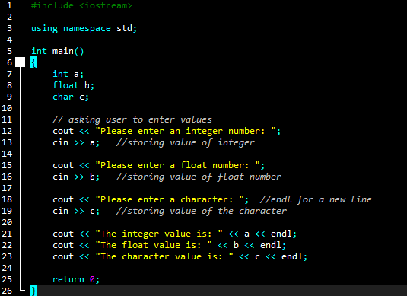

Output:
Please enter an integer number: 1 Please enter a float number: 2.3 Please enter a character: f
The integer value is: 1 The float value is: 2.3 The character value is: f
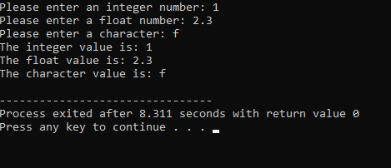

  - : Write a C++ program that takes two int values from the user and computes their sum, difference, product, quotient (division), and the remainder (use mod i.e. %). At the end, print these results on the screen with a beep. Your output should be as below. Indent your code and include comments for improving the readability of your code.
Enter Value 1: 50
Enter Value 2: 50
Sum = 100
Difference = 0
Product = 2500
Quotient = 1
Remainder = 0
Source Code: #include <iostream> using namespace std; int main()
{

int x, y;
cout << "Enter first number: ";
cin >> x; // storing the value of first number
cout << "Enter second number: ";
cin >> y; // storing the value of second number
int sum = x + y; // declaring variables here with data types
int diff = x - y; int mul = x * y; int div = x / y; int mod = x % y;
cout << "Sum is: " << sum << "\a" << endl; // \a makes beep sound
cout << "Difference is: " << diff << "\a" << endl; cout << "Product is: " << mul << "\a" << endl; cout << "Quotient is: " << div << "\a" << endl; cout << "Remainder is: " << mod << "\a";
return 0;
}
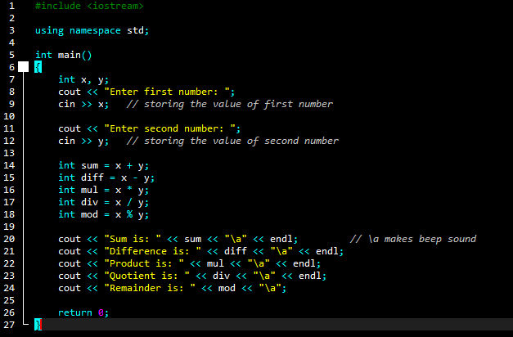

Output:
Enter first number: 1 Enter second number: 2 Sum is: 3
Difference is: -1
Product is: 2
Quotient is: 0
Remainder is: 1
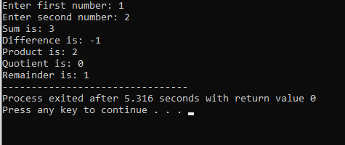

  - : Write a C++ program that takes a temperature value in Celsius as input and converts it to Fahrenheit.
Enter Temperature in Celsius: 42 The temperature in Fahrenheit = 107.6

Hint: (0°C × 9/5) + 32 = 32°F

Source code:
#include <iostream> using namespace std;
int main()
{
float c,f;
cout << "Enter temperature in Celsius: ";

cin >> c; // storing value of temperature in Celsius
f = (c * 9 / 5) + 32; // using formula given
cout << "Temperature in Fahrenheit is: " << f << endl; return 0;
}
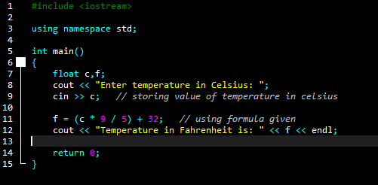

Output:
Enter temperature in Celsius: 55.8 Temperature in Fahrenheit is: 132.44
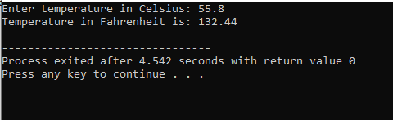

  - : Write a C++ program that takes two int values from the user calculates their sum and then increments it using the pre- Increment operator ++, and finally, prints the result to the standard output.

Enter Value 1: 7
Enter Value 2: 2
Sum = 9
After Increment = 10
Source code: #include <iostream> using namespace std; int main()
{
int a, b;
cout << "Enter first number: "; cin >> a; // storing value
cout << "Enter second number: "; cin >> b; // storing value
int sum = a + b; // declaring sum as a variable
++sum; // adds 1 to sum before use
cout << "The final result is: " << sum << endl; return 0;
}

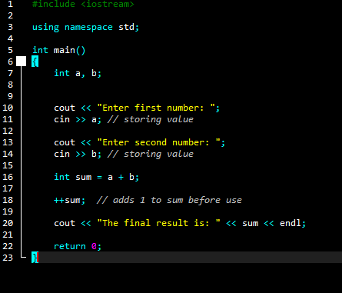

Output:
Enter first number: 6 Enter second number: 7 The final result is: 14
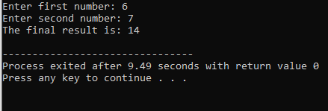

  - : Write a C++ program that takes two int values from the user calculates their sum and then decrements it using the pre-decrement operator --, and finally, prints the result to the standard output.

Enter Value 1: 7
Enter Value 2: 2
Sum = 9
After Decrement = 8

Source Code: #include <iostream> using namespace std; int main()
{
int x, y;
cout << "Enter first number: "; cin >> x;
cout << "Enter second number: "; cin >> y;
int sum = x + y; //adding numbers
--sum; // minus 1 before using it
cout << "The result after pre-decrement is: " << sum << endl; return 0;
}

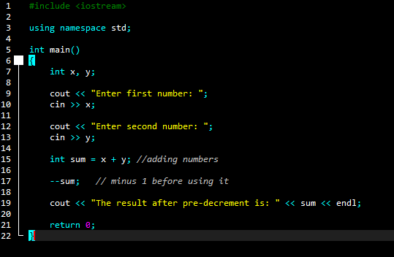

Output:
Enter first number: 5 Enter second number: 8
The result after pre-decrement is: 12
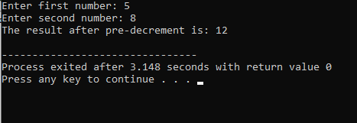

  - : Write a C++ program that collects two integer values from the user, calculates their remainder using the modulo operator (%), and then increments the remainder using the pre- increment operator (++). Display the final remainder on the console.

Enter Value 1: 25
Enter Value 2: 4
Remainder = 1 After Increment = 2

Source code: #include <iostream> using namespace std; int main()
{
int a, b;
cout << "Enter first number: "; cin >> a;
cout << "Enter second number: "; cin >> b;
int r = a % b;
++r; // add 1 before use
cout << "Final remainder after increment is: " << r << endl; return 0;
}

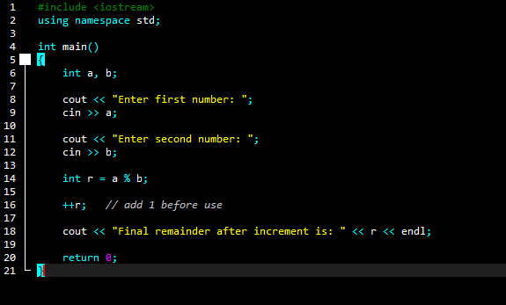

Output:
Enter first number: 7 Enter second number: 3
Final remainder after increment is: 2
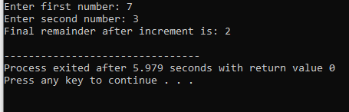

  - : By using different escape sequences, write a C++ program, which displays the following output. After every line, your program must generate a beep. If you already do not know the escape sequence for generating a beep, find it out for yourself. Indent your code and include comments for improving the readability of your code.

BSIET
FA-2023
Your Name Your Section

Hint: cout<<”\tBCIET \n”;

Source Code: #include <iostream> using namespace std; int main()
{
cout << "BSIET \n\a";
cout << "\tFA-2025\n\a"; //tab before FA
cout << "\t\tHunaina Yasir\n\a"; // two tabs before name
cout << "\tSection B \n\a"; // one tab before section
return 0;
}
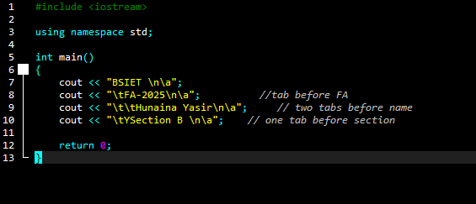

Output:
BSIET
FA-2025
Hunaina Yasir Section B

